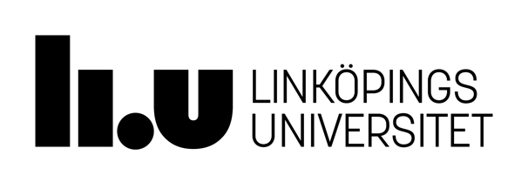

Department of Culture & Society
Institutionen för kultur och samhälle (IKOS)

READING LIST
Spring Semester 2023

Term Paper: Intermediate Course, 7.5 credits
Spring 2023
Course code: 711G49

Course Literature

Compendiums and handouts supplied by the Department.

For literary term papers

Heffernan, James A.W. & John E. Lincoln & Janet Atwill. Writing: A College Handbook, 5th ed. New York: Norton, 2001. [unfortunately this is not up-to-date on revisions to the MLA referencing system – instead consult OWL below]

The Writing Lab and OWL at Purdue and Purdue University (1995-2018) Perdue Online Writing Lab [online] available from https://owl.english.purdue.edu/owl/resource/747/02 [29 December 2019]

For language term papers

Deane, M. Coventry University Harvard Reference Style Guide. Unpublished booklet, 2017. Coventry: Coventry University [online] available from http://www.coventry.ac.uk/study-at-coventry/student-support/academic-support/centre-for-academic-writing [29 December 2019]

Reference Literature

For literary term papers
Bennet, Andrew and Nicholas Royle. Literature, Criticism and Theory, 4th ed. Harlow: Longman, 2009. [ISBN: 9781405859141]

Rapaport, Herman. The Literary Theory Toolkit: A Compendium of Concepts and Methods. Chichester: Wiley-Blackwell, 2011. [ISBN: 9781405170475]

For language term papers
Benati, Alessandro G. Key Methods in Second Language Acquisition Research. Sheffield, UK: Equinox, 2015.

Litosseliti, Lia, ed. Research Methods in Linguistics. London: Continuum International Publishing Group, 2010.

Paltridge, Brian & Phakiti, Aek, eds. Research Methods in Applied Linguistics: A Practical Resource. London: Bloomsbury, 2015.

See also the left-hand column of the Language Term Paper course room for more specific suggestions.

